1. Showing successful configuration of auditing for “Success and Failure” for both logon events.

1. Graphical user interface, text, application, email

   Description automatically generatedApplication of larger maximum log size for the Security event log.
2. The IP address of the remote user is 108.51.126.17.
3. The user-agent string is “Mozilla/5.0 (compatible; Nmap Scripting Engine; https://nmap.org/book/nse.html)”.
4. 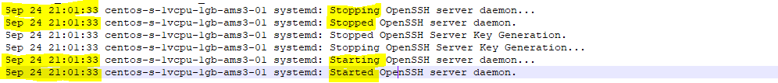The date and time that the stopping and restarting occurred is September 24th at 21:01:33.